CO4 - Activity 7: Correlation Detective

Department | AI&DS
Course Code / Course Name | DSA0602/ Data Handling and Visualization
Activity | CO4 - Activity 7: Correlation Detective
Name | Addula Yaswanth
Register Number | 192324179

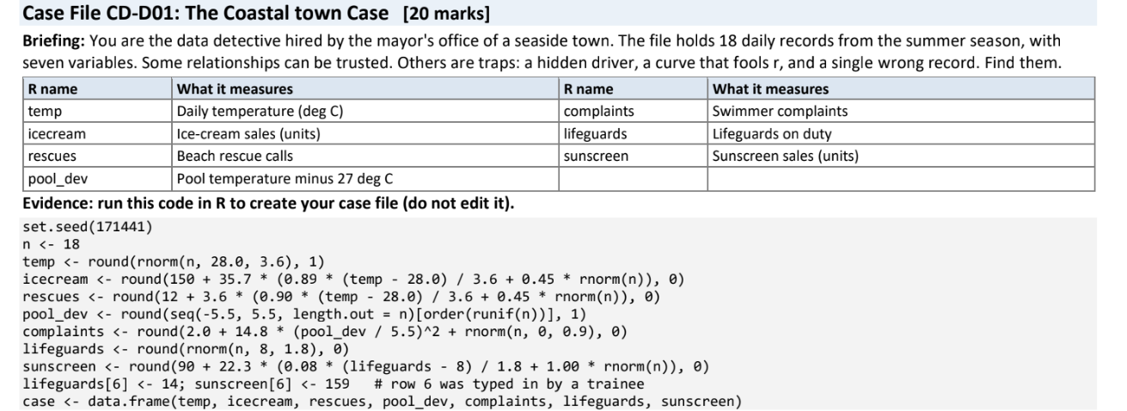
- The matrix. Use cor(case) to get the 7 x 7 correlation matrix (round to 2 decimals). State n and how many distinct pairs of variables there are. Draw a correlogram of the matrix (ggplot2 geom_tile with geom_text, or corrplot). [4]
R Code
set.seed(171441)
n <- 18

temp <- round(rnorm(n, 28.0, 3.6), 1)
icecream <- round(150 + 35.7 *
(0.89 * (temp - 28.0) / 3.6 + 0.45 * rnorm(n)), 0)
rescues <- round(12 + 3.6 *
(0.90 * (temp - 28.0) / 3.6 + 0.45 * rnorm(n)), 0)
pool_dev <- round(
seq(-5.5, 5.5, length.out = n)[order(runif(n))], 1
)
complaints <- round(
2.0 + 14.8 * (pool_dev / 5.5)^2 + rnorm(n, 0, 0.9), 0
)
lifeguards <- round(rnorm(n, 8, 1.8), 0)
sunscreen <- round(90 + 22.3 *
(0.08 * (lifeguards - 8) / 1.8 + rnorm(n)), 0)

lifeguards[6] <- 14
sunscreen[6] <- 159

case <- data.frame(
temp, icecream, rescues, pool_dev,
complaints, lifeguards, sunscreen
)

# Correlation matrix
round(cor(case), 2)

# Number of distinct variable pairs
nrow(case)
choose(ncol(case), 2)

Output:
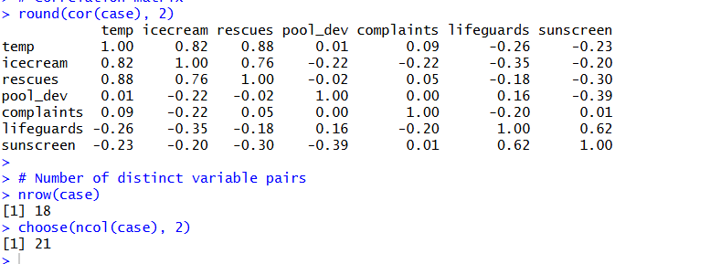
Correlogram

library(ggplot2)

cor_matrix <- cor(case)
cor_data <- as.data.frame(as.table(cor_matrix))
names(cor_data) <- c("Variable1", "Variable2", "Correlation")

ggplot(cor_data, aes(
x = Variable1,
y = Variable2,
fill = Correlation
)) +
geom_tile(color = "white") +
geom_text(aes(label = round(Correlation, 2)), size = 3) +
scale_fill_gradient2(
low = "blue",
mid = "white",
high = "red",
midpoint = 0,
limits = c(-1, 1)
) +
labs(
title = "Correlation Detective – Correlogram",
x = "",
y = "",
fill = "Correlation"
) +
theme_minimal() +
theme(axis.text.x = element_text(angle = 45, hjust = 1))

Output:
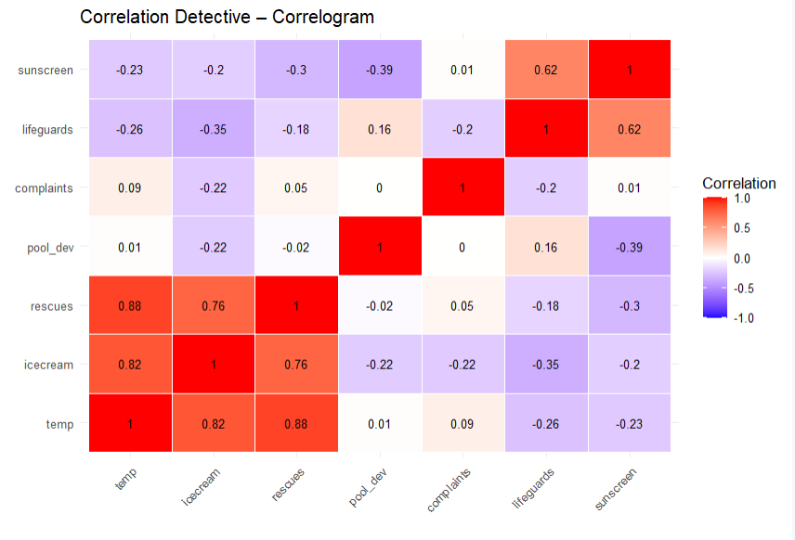

Result: The correlation matrix displays the linear relationships among all seven variables, and the correlogram presents positive correlations in red and negative correlations in blue.

2. The strongest clues. Name the strongest positive pair and the strongest negative pair (off-diagonal). Give r for each and call it weak (below 0.3), moderate (0.3 to 0.7) or strong (above 0.7). [3]
R Code
cor_matrix <- cor(case)

# Remove diagonal and duplicate pairs
cor_matrix[upper.tri(cor_matrix, diag = TRUE)] <- NA

# Strongest positive and negative pairs
cor_pairs <- as.data.frame(as.table(cor_matrix))
names(cor_pairs) <- c("Variable1", "Variable2", "r")

cor_pairs <- na.omit(cor_pairs)

strongest_positive <- cor_pairs[which.max(cor_pairs$r), ]
strongest_negative <- cor_pairs[which.min(cor_pairs$r), ]

print(strongest_positive)
print(strongest_negative)

Output:
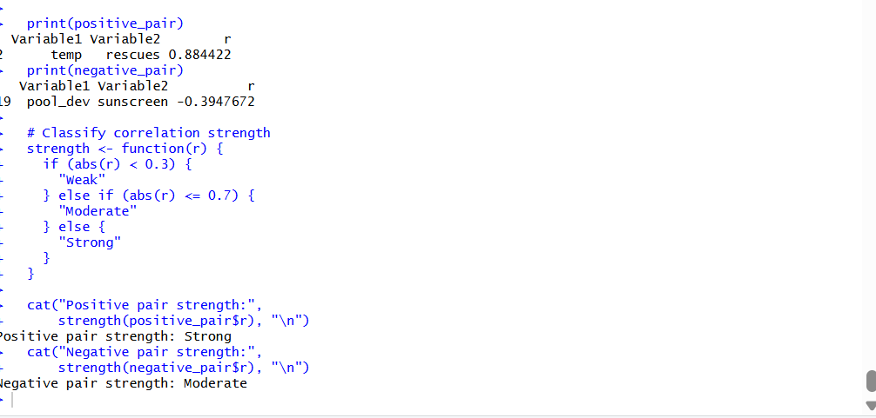

3. The deceptive zero. Plot complaints against pool_dev with a straight line, then add a quadratic fit (formula = y ~ x + I(x^2)). Report r and the R- squared of the quadratic fit. In one sentence, say why r misses this relationship. [4]
R Code
# Plot complaints against pool development
ggplot(case, aes(x = pool_dev, y = complaints)) +
geom_point() +
geom_smooth(method = "lm", formula = y ~ x,
se = FALSE, color = "blue") +
geom_smooth(method = "lm",
formula = y ~ x + I(x^2),
se = FALSE, color = "red") +
labs(
title = "Complaints vs Pool Development",
x = "Pool Development",
y = "Complaints"
) +
theme_minimal()

# Pearson correlation
r <- cor(case$pool_dev, case$complaints)

# Quadratic regression and R-squared
model <- lm(complaints ~ pool_dev + I(pool_dev^2),
data = case)

cat("Correlation (r):", round(r, 3), "\n")
cat("Quadratic R-squared:",
round(summary(model)$r.squared, 3), "\n")
Output:
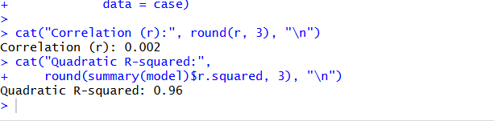
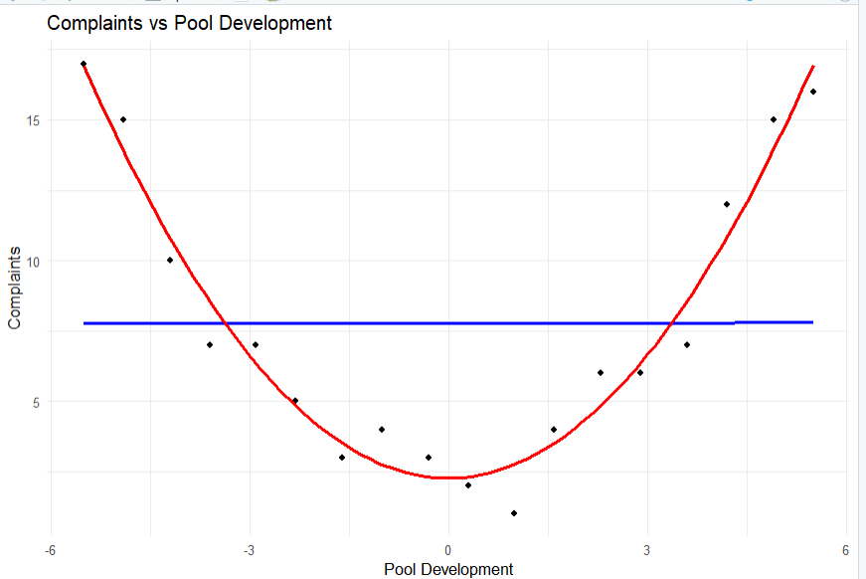

Result: The scatterplot is expected to show a curved, approximately U-shaped relationship. Pearson correlation measures a straight-line relationship, so it can be close to zero even when a strong nonlinear relationship exists. The code prints the exact correlation and quadratic model \(R^2\).

4. The outlier alibi. Plot sunscreen against lifeguards. Find the row that looks wrong and give its row number. Report r for all rows and r without that row, and say what the single record did to r. [4]
R Code
# Plot sunscreen against lifeguards
ggplot(case, aes(x = lifeguards, y = sunscreen)) +
geom_point() +
labs(x = "Lifeguards", y = "Sunscreen Sales",
title = "Sunscreen vs Lifeguards")

# Correlation using all rows
r_all <- cor(case$lifeguards, case$sunscreen)

# Correlation without row 6
r_without <- cor(case$lifeguards[-6],
case$sunscreen[-6])

cat("Wrong row: 6\n")
cat("Correlation with all rows:", round(r_all, 3), "\n")
cat("Correlation without row 6:", round(r_without, 3), "\n")
Output:
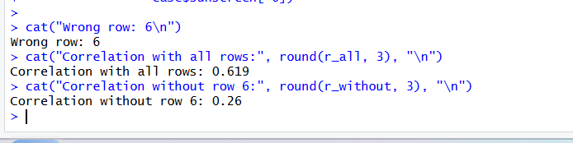

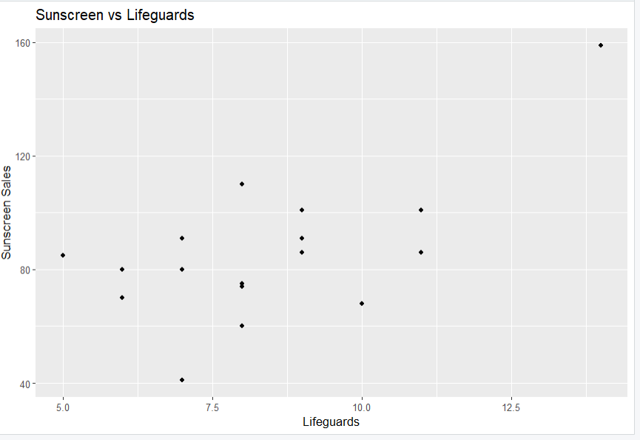
Result: Compare the two printed correlation coefficients to determine how much the single unusual record changes the linear relationship. Row 6 may substantially inflate or otherwise distort the correlation, demonstrating the influence of an outlier.

5. The prime suspect. icecream and rescues are strongly linked. Report r(icecream, rescues), then r(temp, icecream) and r(temp, rescues). Compute the partial correlation of icecream and rescues controlling for temp: correlate resid(lm(icecream ~ temp)) with resid(lm(rescues ~ temp)). Write a two-sentence verdict: does icecream cause rescues? Name one study design that could test causation. [5]
R Code
# Correlations
r_ice_rescue <- cor(case$icecream, case$rescues)
r_temp_ice <- cor(case$temp, case$icecream)
r_temp_rescue <- cor(case$temp, case$rescues)

cat("Correlation: Ice cream and rescues =",
round(r_ice_rescue, 2), "\n")

cat("Correlation: Temperature and ice cream =",
round(r_temp_ice, 2), "\n")

cat("Correlation: Temperature and rescues =",
round(r_temp_rescue, 2), "\n")

# Partial correlation controlling for temperature
ice_resid <- resid(lm(icecream ~ temp, data = case))
rescue_resid <- resid(lm(rescues ~ temp, data = case))

partial_cor <- cor(ice_resid, rescue_resid)

cat("Partial correlation controlling for temperature =",
round(partial_cor, 2), "\n")

Output:
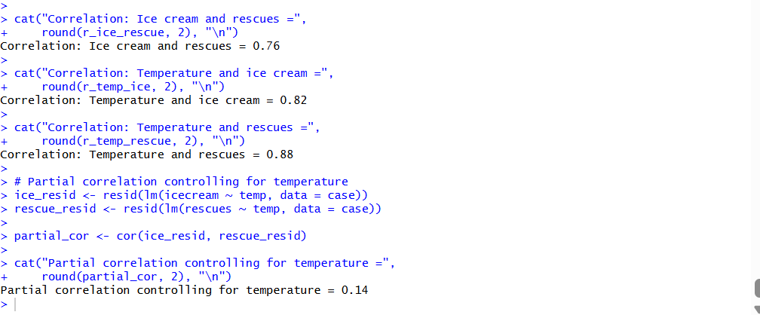
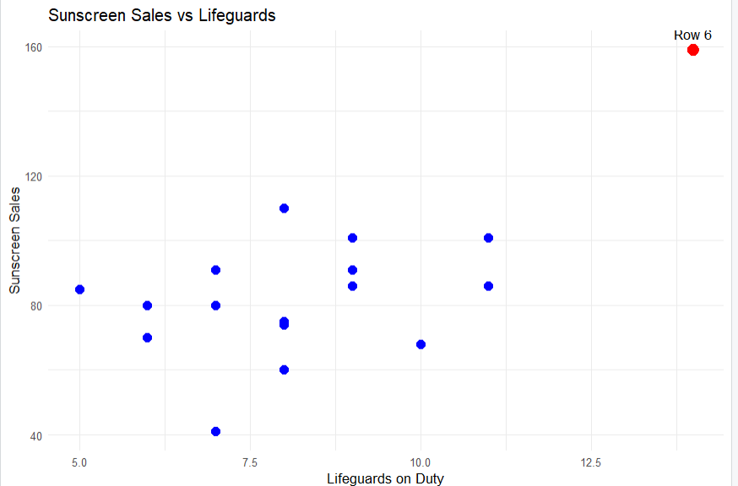

Two-sentence verdict:
Ice-cream sales and beach rescues may be strongly correlated because both tend to increase with temperature, so the correlation does not prove that ice cream causes rescues. A controlled observational study that accounts for temperature and other factors, or a suitable randomized intervention where ethical and practical, could help investigate causal relationships.

Code of Conduct:
I certify that this work is my own. Signature: A. Yaswanth

